1 This project involves using the GPIO pins on the Raspberry and a PiDie Shield to create a “Simon Says” Game. The PiDie shield is available from 4tronix.co.uk and comprise a set of LED’s and Switches mounted on a Shield.

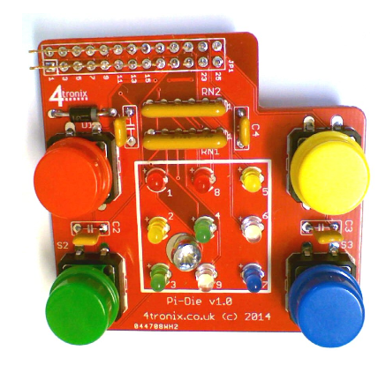

2 The PiDie can be attached directly to your Pi, whilst still making the Pins available (depending on model)

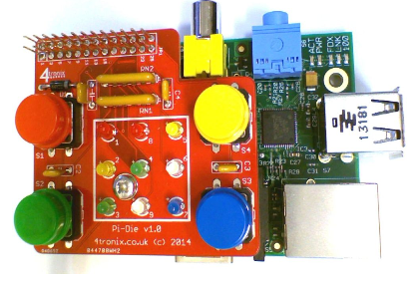

3 PiDie LEDs and buttons need to be mapped. The latest GPIO library for Scratch 1.4 uses GPIO numbering, use the following table to work out how to address the LED’s

Led1: 7 - GPIO - 4

Led2: 11 - GPIO - 17

Led3: 12 - GPIO - 18

Led4: 13 - GPIO - 21 for model A, 27 for later models

Led5: 15 - GPIO - 22

Led6: 16 - GPIO - 23

Led7: 18 - GPIO - 24

Led8: 22 - GPIO - 25

Led9: 8 - GPIO - 14

Buttons on physical pins as follows:

Red: 21 - GPIO - 9

Green: 19 - GPIO - 10

Yellow: 24 - GPIO - 8

Blue: 26 - GPIO - 7

4 Some sample Scratch programs have been provided to get you going. These are located along with this document, and is also available in the Scratch members area.

**PiDieGPIOLEDs.sb** - Uses the number keys on keyboard to turn same number LED on and off. Updated for GPIO headers.

**PiDieGPIOButtons.sb** - Switches on the LED next to each button when the button is pressed. Updated for GPIO headers.

5 Are you up for a challenge? - A sample Scratch Simon Says program is available but this needs updating to the latest GPIO pin outs. Take this program and update it, or better still come up with your own!

**Simon_SDM.sb -** A complete Simon game: By Sjoerd Dirk Meijer - @fromScratchEd from <http://scratch.mit.edu/projects/11939445/> (still using Cymplecy GPIO conventions)

More information can be found at the following sites:

<http://scratch.mit.edu/projects/11939445/>

<http://4tronix.co.uk>